**GitHub Link:**

Create a PKI – Infrastructure (Signing- CA, Root-CA, and TLS certificate)

1. Creating a “crl” and “cert” directory to host certificate and crls

1. Creating folder for databases and key for the “root-ca”

1. Creating a root- CA request and the private key

(The PEM pass phrase is the “.key” file generated)

1. Certificate for self is created and updated in Db by the CA.

1. Creating a signing CA

1. Creating a database

1. Create a signing CA request

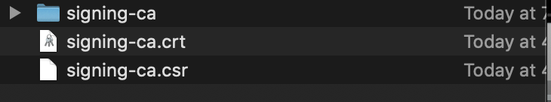

1. Using Root CA private key to get signing-ca certificate from root-ca

1. To create a TLS- server request

1. To create TLS- server certificate

